Curd Incubation From Alfa Tech India:

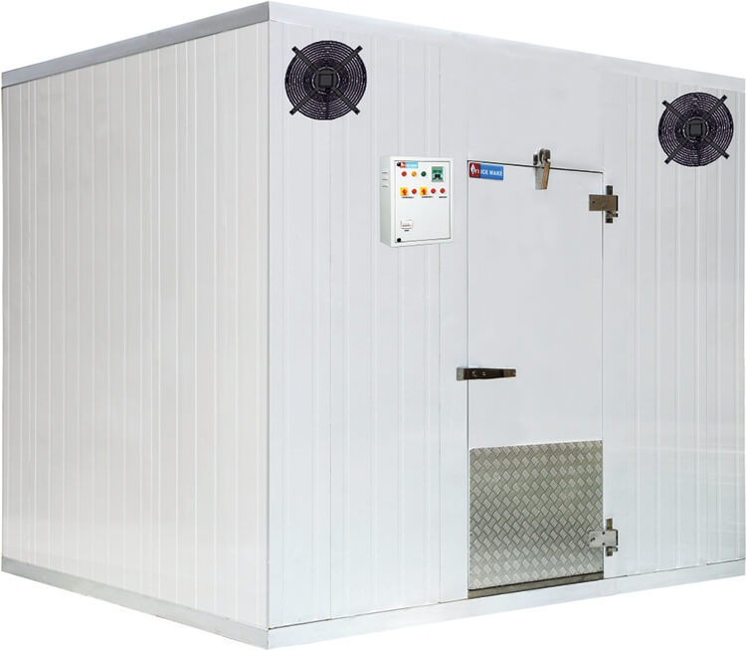

CURD INCUBATION:
We are providing fully automatic combo type incubation chambers with heating and cooling both process together in single chamber.

Sr. No. | Model |  | Storage  Capacity  (Ltr/Batch) | Size(inch) | Body Type | Temperature  while  Heating | Temperature  re while  Cooling
1 |  | WI-1200 | 1250 | 70" X 70" X 97.22"  (W X DX H) | Combo -  Walk in Type | 32°C to 45° C | -5°C to 8° C

- Application : Curd Incubation / Blast Chilling/Storage
- Standard Incubation time is approx. 4 hours but it will depend upon the packing type and loading temperature of curd with a condition that the chamber temperature should be 45° C before loading .
Standard cooling time is approx. 5 hours but it will depend upon the packing type and loading temperature of curd with a condition that timing will be considered after getting chamber temperature as 2° C.
- OPTION FOR ONLY INCUBATION IS AVAILABE FOR ALL UNITS

Procedure to produce best quality curd

- In our indian culture, 'dahi' (Gujrati, Marathi, Nepali, Punjabi, Urdu), 'dohi' (Oriya), Mosou (Kannada) or thayir (Tamil) is the yogurt of India, know for its characteristic, sweet tart test semi sold consistency. It is also Religiously as well as Scientifically proven good for health.

But

- We cant retain its test and quality equal due to variations in indian weather conditions and slight deviations in procedure so as a solution of that Ice Make provides you exact methodology with appropriate temperature conditions on base of our wide experience and some expert's advice

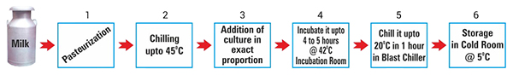

- Stage No.4 and 5 in above method is most important
- Alfa Tech India offers your exact solution for stage No. 4 and 5 and of couse for stage No.6 also.
- We offers you Incubation room with hot unit (as shown in photograph above) which can maintain 42°Cwith 1°Cdeviation for stage No.4
- For stage No.5 our Blast Chiller is useful to chill the culture upto 20°Cwithin 1 hour
- At last, for stage No.6 you can use our regular cold room.
If you will prepare curd according to above procedure, you will get curd with same test & quality in every season which can maintain its quality for long time and you can prepare delicious Indian Items like Lassi, Raita, Shrikhand, Kari etc. which will have best quality.

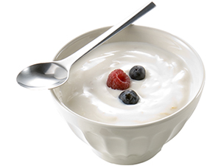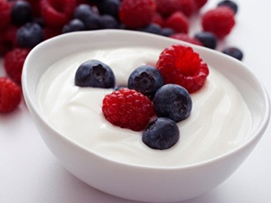

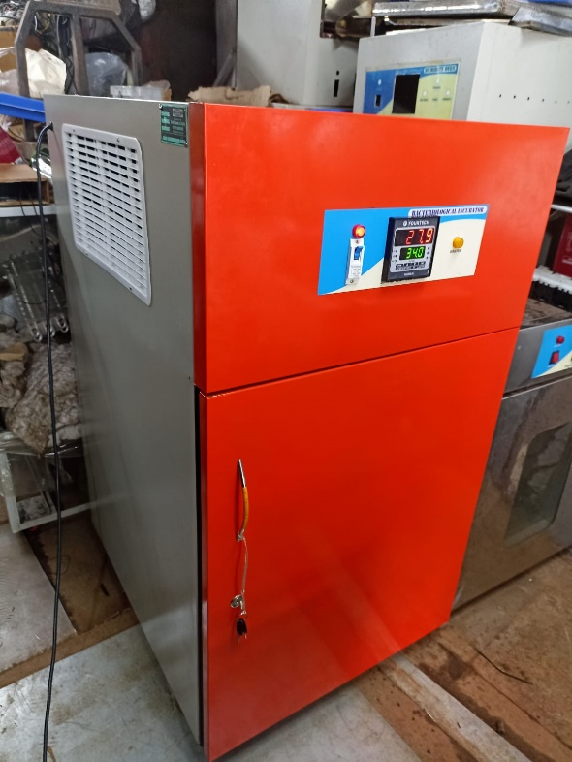

ADD MORE INFORMATION AS ABOVE

